10.07
CUSTOMER MATERIAL
Process Design & AMOS Configuration Document
Purpose
This Process Design document is provided to Key-Users to record their key decisions regarding the AMOS Process design and the required AMOS configuration.
It is updated throughout the Project Definition Phase and used as the baseline for the Final Acceptance prior to Go-Live
Revision
Author, Name | Date | Notes
Paulo Reuter Perine | 01.06.2024 | First version

Table of Contents
1. Process Overview & Objectives 3
2. Regulatory References 3
3. Definitions & Glossary 3
4. Process Tasks 3
5. Process Dependencies 4
6. Process Flow 5
7. Process Design Questions 6
8. Data Source Mapping 7
9. Other Software Used 7
10. AMOS Configuration 7
a. Process specific configuration programmes 7
b. Basic Data 7
c. Parameters 7
d. Workflows 7
e. Scheduled Tasks 8
f. API’s & Interfaces 8
11. UAT Guidance 8
12. Annex – Additional Info 9

Process Overview & Objectives
Process General Description:
This process defines the steps to manage all incoming customer material, from unserviceable customer components to perform maintenance in your component shops, or provisioning of material to fulfil part requests coming from a customer aircraft performing maintenance at your facilities. This process also covers parts that are removed from a customer aircraft when performing an aircraft workpackage and requires maintenance work to be performed in a shop environment.
It covers the whole process, from creation of the customer order, receive this order, move the material in your store, pick the material to be used for maintenance and returning the parts to your customer.
Main Process Objective (Outputs & Outcomes):
The primary objective of this process is to ensure customer material traceability. To achieve this, each material sent by your customer needs to be linked with the appropriate order, being RC order when a unit is shipped U/S to perform maintenance at your component shops, R order when the unit is removed when performing maintenance in your facilities, or CP order when your customer sends serviceable parts for provisioning for an aircraft Workpackage to be executed in your facilities.

Regulatory References
There is no worldwide authority regulation applicable to this process.

Definitions & Glossary
Key-Words | Explanation
APN | AMOS Program Number
CMWP | Component Maintenance Workpackage created in AMOS
CP | Customer Provision Order
CU | Customer Provision Return Order
R | Repair Order
RC | Customer Repair Order
RU | Customer Repair Return Order
U/S | Unserviceable
WP | Aircraft Workpackage created in AMOS

Process Tasks
Business Process Task / Actions / Activities:
- Receive customer material for shop input: Create a RC order to make this shipment visible in AMOS and to trigger the receiving goods process for the material listed in the order. Once received you can move the material to the appropriate shop, perform maintenance, request material to execute maintenance, release the component, prepare to ship the unit back to the customer by using a RU order that is automatically created and linked to the RC order, ship it out and invoice your services.
- Handle provisioning of parts sent from customer: Create a CP order to enable traceability from the moment the parts are shipped to you. Once received you need to receive the order, move to your store, use when requested by maintenance making sure the parts is used only for that particular customer, and once the WP is complete and you still have parts in your stock, you can initiate the return of such parts back to your customer by using a CU order that is automatically created and linked to the CP order.
- Handle part removed from customer A/C maintenance input: Once a component is removed when performing a WP, you must create a R order to trigger the repair process for that unit. This will create traceability from the removal of the part, the repair of the unit, until it is installed back at the aircraft, or if the part was replaced by another part at the aircraft, to ship the unit back to your customer.

Process Dependencies
INPUT | CONCURRENT | OUTPUT
- 12.05b – Customer Quotations: Define material fulfilment agreement for the requested work scope.  - 10.01 – Logistics: Track the shipment of the part until it arrives at your receiving department.  - 10.02 – Goods Receiving and Inspection: Receive the part, check paperwork, and move the part to your store.  - 10.03 – Major Assemblies: Receive the major assembly with as much details as needed to execute the agreed work scope.  - 08.02 – Performing Maintenance: Create part to remove to initiate repair process. | - 08.02 – Performing Maintenance: Issue part request to be fulfilled by the customer material available in your stock.  - 11.04 – Component Maintenance: Issue part requests to be fulfilled by the customer material available in your stock. | - 10.01 – Logistics: Return non used parts from CP order; or return customer component from RC or R order.  - 12.04 – Commercial Pricing and Billing: Bill your services to your customer.

Process Flow
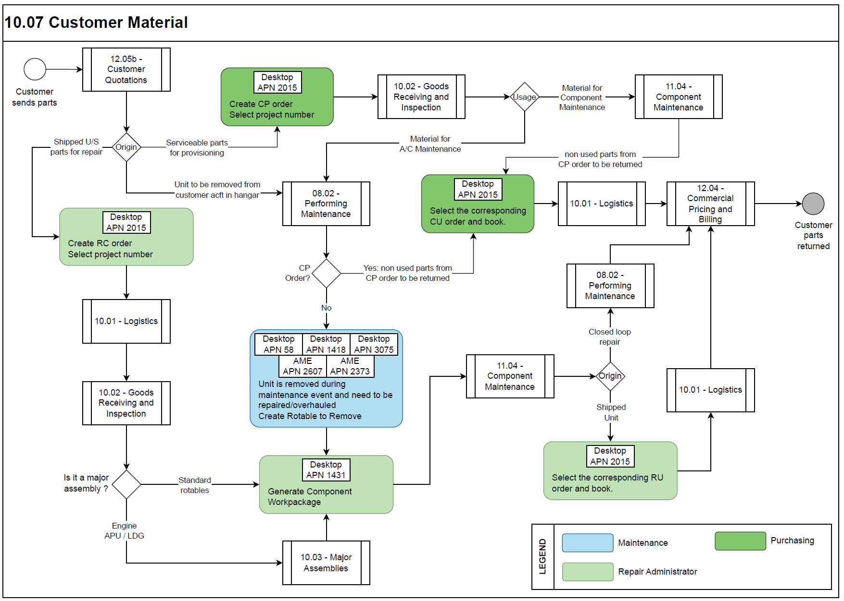

Process Design Questions
# | Question | Answer
1 | Do you receive customer provisioning parts to be used to perform maintenance on their aircraft?  If yes, please describe the current process to me.
2 | When receiving customer provisioning parts, who creates the order to have traceability on this units being sent to you?
3 | Who creates the customer provisioning return order?
4 | When a customer agrees to send a component to perform repair at your shops, who creates the customer repair order?
5 | How do you identify and manage customer parts in your store?
6 | How many customer material to you receive per year?  - To perform component repair.  - To be used at customer aircraft.
7 | What is the ratio of customer provisioned parts that are returned to customer when work is completed?
8 | Who creates the component repair return order?
9 | Do you need to report customer provisioning stock levels regularly during the time you have their parts in your stock?

Data Source Mapping
Data Sources | Description | Volume / Manual / Automatic / Static / Dynamic
-/- | -/- | -/-

Other Software Used
Other Software | Used by: | Description
-/- | -/- | -/-

AMOS Configuration

Process specific configuration programmes
AMOS APN | Notes
-/- | -/-

Basic Data
Basic Data Table | Notes
Condition | Indicates the condition of a rotable relative to its traceability as it moves through its life cycle process.
Order Priority | Priorities used on every order. Codes like AOG, CRITICAL etc. is entered here.

Parameters
Parameter Code | Parameter Name | Notes
-/- | -/- | -/- | -/-

Workflows
Workflow Number | Workflow Name | Workflow Setup Notes
-/- | -/- | -/-

Scheduled Tasks
Scheduled Task Reference | Frequency | Notes
-/- | -/- | -/-

API’s & Interfaces
Reference | Direction | Trigger | Frequency
-/- | -/- | -/- | -/-

UAT Guidance
Test case number | Test case description | Required data | Required resources
01 | Create a customer quotation to cover an aircraft WP to be performed at your facilities. | -/- | Sales Department
02 | Crete a CP order with parts to be used during the execution of your customer WP. | -/- | Purchasing
03 | Receive the CP order and make it available in your stock. | -/- | Storemen
04 | When performing maintenance for this aircraft issue part requests and confirm if the required part has been provided in the CP order and use the parts from the CP order. | -/- | Aircraft Mechanic
05 | Remove a rotable part (replacement part not provided in a CP order). | -/- | Aircraft Mechanic
06 | Create a R order and send to be repaired in a shop. | -/- | Repair Admin
07 | Once the part is repaired form shop, reinstall the unit back at the aircraft. | -/- | Aircraft Mechanic
08 | Close and release the WP and | -/- | Aircraft Mechanic
09 | Initiate the CU order process. | -/- | Purchasing
10 | Create a RC order to repair a component that has been shipped to you by your customer. | -/- | Repair Admin
11 | Receive and inspect the component and send to your shop to be repaired. | -/- | Storemen
12 | Close the CMWP and release the component. | -/- | Shop Mechanic
13 | Initiate the RU order process to return the component back to customer. | -/- | Logistics

Annex – Additional Info
-/-

